SELECT * FROM transaksi ORDER BY tgl_transaksi ASC

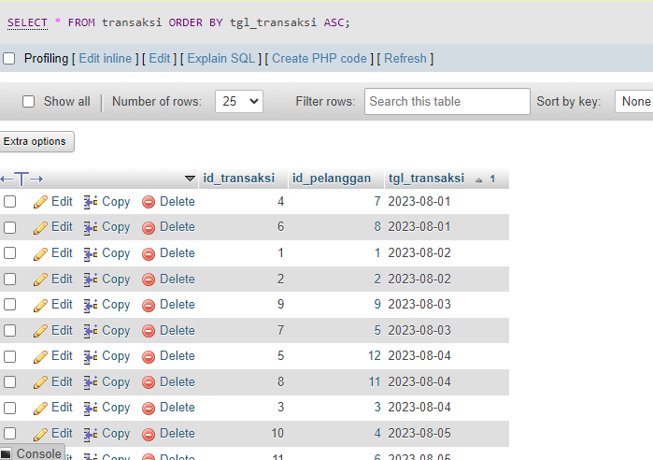

SELECT * FROM transaksi ORDER BY id_pelanggan DESC

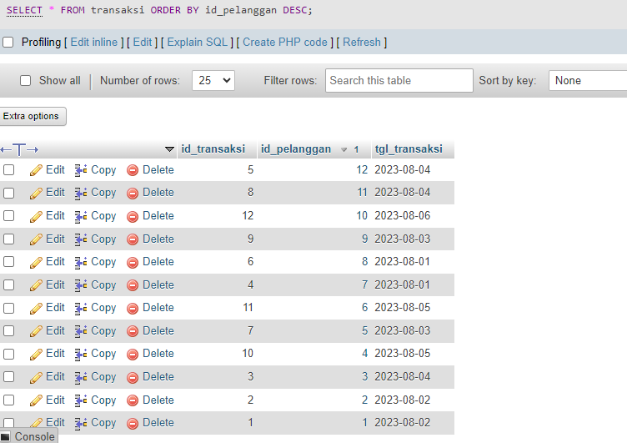

SELECT * FROM pelanggan WHERE nama_pelanggan LIKE "j%"

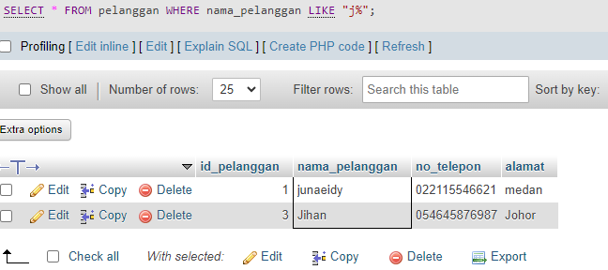

SELECT * FROM pelanggan WHERE nama_pelanggan LIKE "erna%"

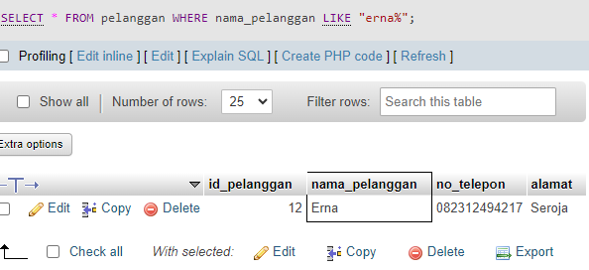

SELECT id_produk, SUM(stok) as total FROM `produk` GROUP BY id_produk

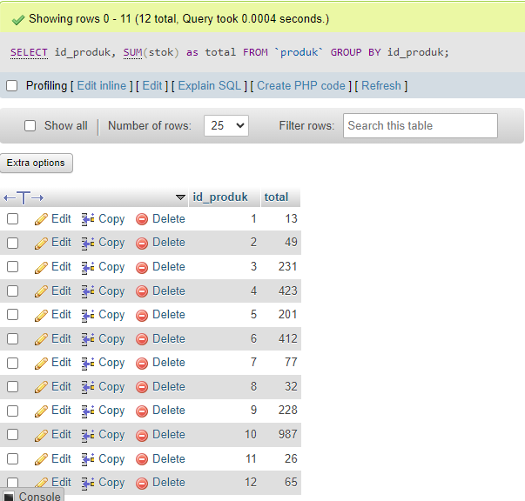

SELECT nama_produk, SUM(stok) as total FROM `produk` GROUP BY nama_produk

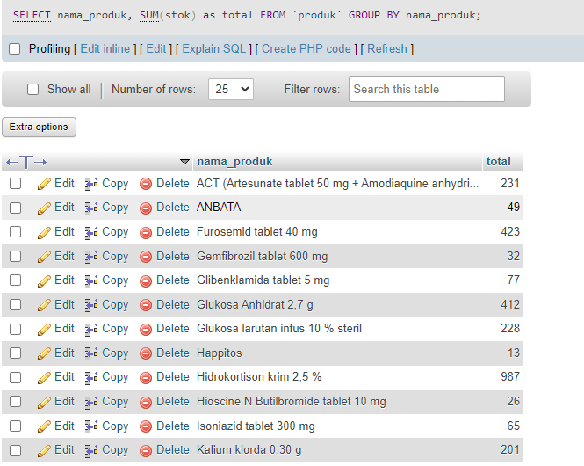

SELECT tgl_transaksi, SUM(id_pelanggan) AS total FROM transaksi WHERE tgl_transaksi >= 2023-08-01 GROUP BY tgl_transaksi ORDER BY tgl_transaksi ASC

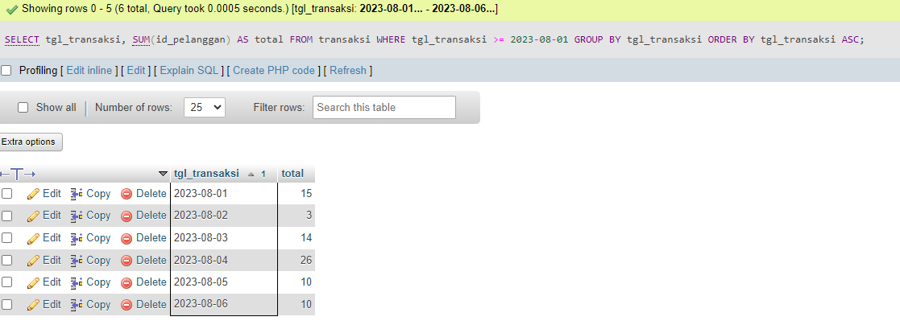

SELECT tgl_transaksi, SUM(id_pelanggan) as total FROM transaksi GROUP BY tgl_transaksi

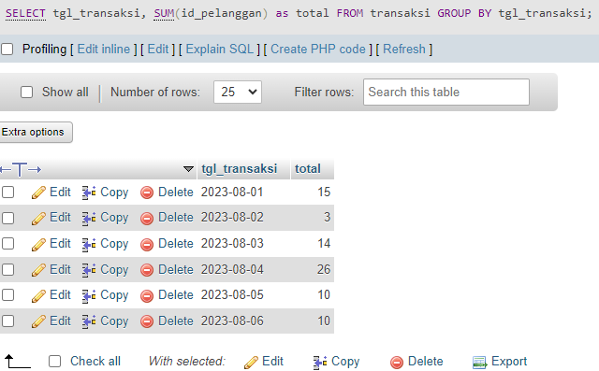

SELECT * FROM pelanggan WHERE alamat IN ("medan","helvetia")

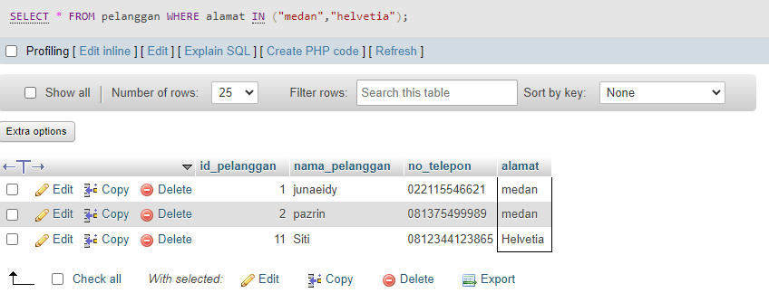

SELECT * FROM produk WHERE stok BETWEEN 15 and 201 ORDER BY stok ASC

